Designing a scalable, efficient, and well-structured database for a To-Do App requires careful planning. Below are key insights that ensure data integrity, performance, and flexibility.

1. IDENTIFY CORE ENTITIES
A To-Do App typically involves the following key entities:
1. Users → Manages user authentication and personalization.
2. Tasks → Stores the actual to-do items.
3. Labels (Tags) → Organizes tasks into categories.
4. Task Reminders → Manages notifications for due tasks.
5. Subtasks (Optional) → Supports hierarchical task management.

2. DATABASE SCHEMA DESIGN PRINCIPLES
a. Use Normalization to Reduce Redundancy
- Separate users and tasks to avoid duplicating user data.
- Use a Many-to-Many relationship for labels (via a linking table).
- Store timestamps for tracking changes (e.g., created_at, updated_at).
b. Optimize for Performance
- Index foreign keys (user_id, task_id) to speed up lookups.
- Use ENUM for status fields (e.g., "pending", "completed").
- Denormalization for analytics (e.g., store "task count per user" in Users table).
c. Ensure Data Integrity & Consistency
- Use Foreign Keys for relationships to maintain referential integrity.
- Use ON DELETE CASCADE to remove related tasks when a user deletes their account.
- Use UUIDs instead of auto-incremented IDs for better security in a distributed system.

Recommended Database Schema (SQL Example)
USERS TABLE (STORES USER INFORMATION.)

CREATE TABLE Users (
id INT PRIMARY KEY AUTO_INCREMENT,
username VARCHAR(50) UNIQUE NOT NULL,
email VARCHAR(100) UNIQUE NOT NULL,
password_hash VARCHAR(255) NOT NULL,
created_at TIMESTAMP DEFAULT CURRENT_TIMESTAMP,
updated_at TIMESTAMP DEFAULT CURRENT_TIMESTAMP ON UPDATE CURRENT_TIMESTAMP
);

TASKS TABLE (STORES TASK DETAILS.)
CREATE TABLE Tasks (
id INT PRIMARY KEY AUTO_INCREMENT,
user_id INT NOT NULL,
title VARCHAR(255) NOT NULL,
description TEXT,
status ENUM('pending', 'completed', 'archived') DEFAULT 'pending',
priority ENUM('low', 'medium', 'high') DEFAULT 'medium',
due_date DATETIME DEFAULT NULL,
created_at TIMESTAMP DEFAULT CURRENT_TIMESTAMP,
updated_at TIMESTAMP DEFAULT CURRENT_TIMESTAMP ON UPDATE CURRENT_TIMESTAMP,
FOREIGN KEY (user_id) REFERENCES Users(id) ON DELETE CASCADE
);

TASK LABELS (TAGS) TABLE
For task categorization.
CREATE TABLE Labels (
id INT PRIMARY KEY AUTO_INCREMENT,
user_id INT NOT NULL,
name VARCHAR(50) NOT NULL,
FOREIGN KEY (user_id) REFERENCES Users(id) ON DELETE CASCADE
);

Task-Label Relationship Table
A Many-to-Many relationship between Tasks and Labels.

CREATE TABLE Task_Label_Map (
task_id INT NOT NULL,
label_id INT NOT NULL,
PRIMARY KEY (task_id, label_id),
FOREIGN KEY (task_id) REFERENCES Tasks(id) ON DELETE CASCADE,
FOREIGN KEY (label_id) REFERENCES Labels(id) ON DELETE CASCADE
);

REMINDERS TABLE (OPTIONAL) FOR TASK REMINDERS.
CREATE TABLE Reminders (
id INT PRIMARY KEY AUTO_INCREMENT,
user_id INT NOT NULL,
task_id INT NOT NULL,
notification_time DATETIME NOT NULL,
status ENUM('pending', 'sent') DEFAULT 'pending',
FOREIGN KEY (user_id) REFERENCES Users(id) ON DELETE CASCADE,
FOREIGN KEY (task_id) REFERENCES Tasks(id) ON DELETE CASCADE
);

4. Additional Optimizations
✅ Indexes for Faster Query Performance
CREATE INDEX idx_tasks_user ON Tasks(user_id);
CREATE INDEX idx_task_due_date ON Tasks(due_date);

✅ Views for Quick Data Retrieval
Create a view to quickly fetch pending tasks per user.
CREATE VIEW pending_tasks AS
SELECT t.id, t.title, t.status, t.due_date, u.username
FROM Tasks t JOIN Users u ON t.user_id = u.id
WHERE t.status = 'pending';

✅ JSON Storage (For NoSQL or Hybrid Approach)
If using MongoDB, store tasks in a document-based format:
json
{
"_id": "task_id",
"user_id": "user_id",
"title": "Task Title",
"description": "Optional",
"status": "pending",
"priority": "medium",
"due_date": "2025-02-01T12:00:00Z",
"labels": ["work", "urgent"]
}

SCHEMA TABLE FOR TO-DO-APP (FRONT END DEVELOPMENT)
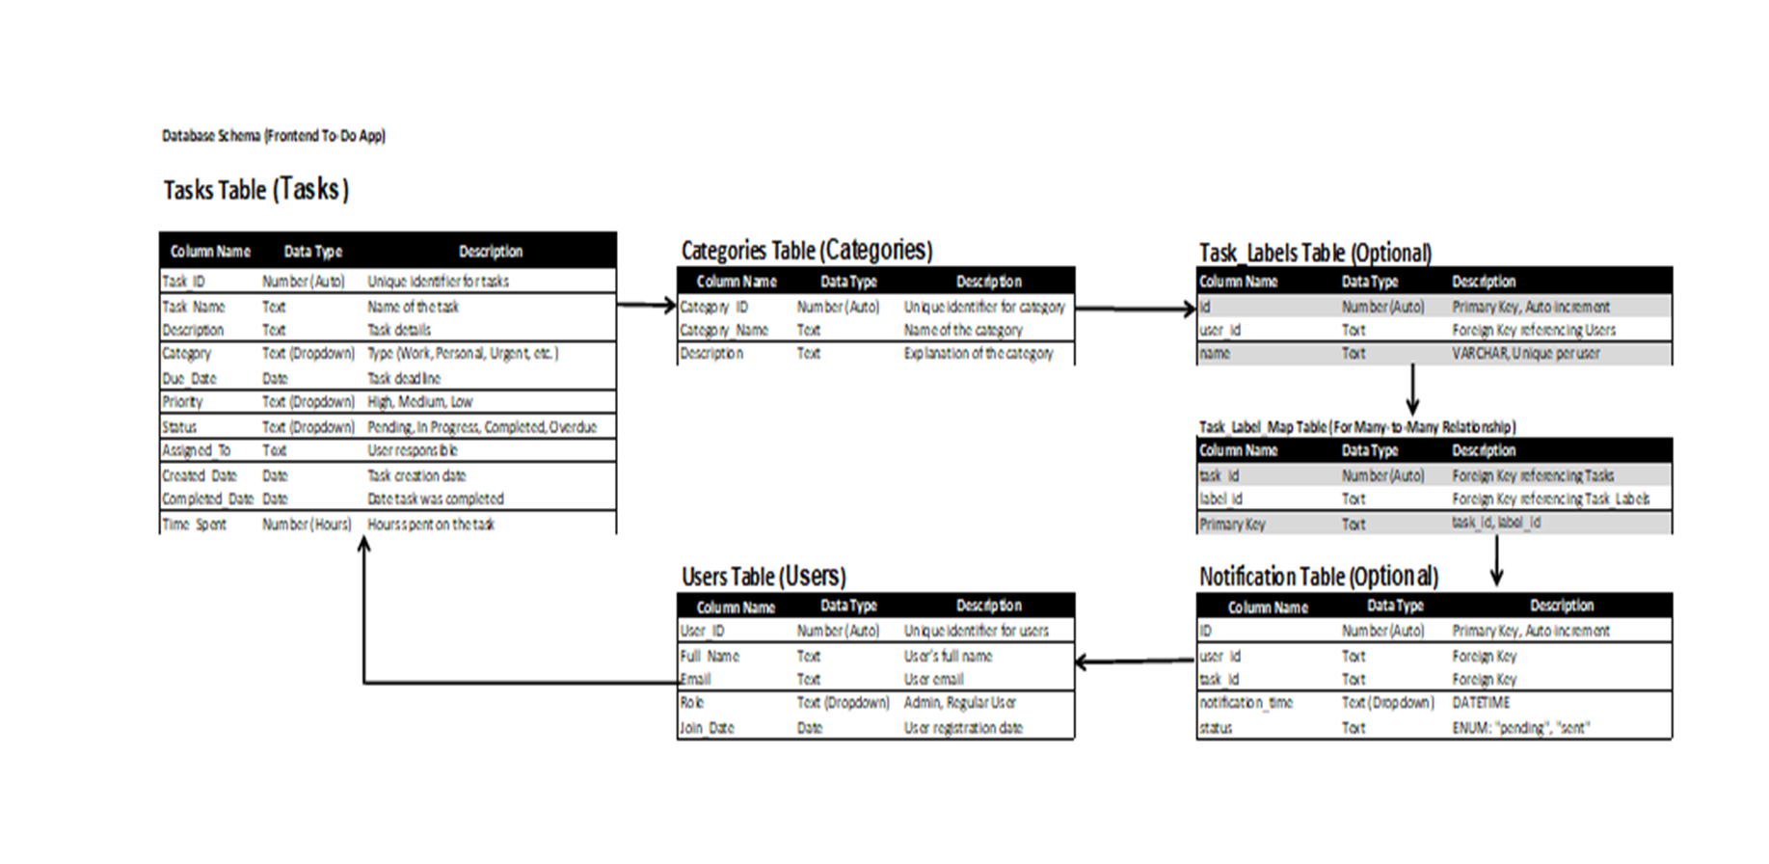
Database Schema (Frontend To-Do App)

Here’s an Entity-Relationship Diagram (ERD) for a To-Do App. It visually represents how the database tables are related.

Entities & Relationships in the ERD
- Users → Users who manage their tasks.
  - One-to-Many: A user can have multiple tasks.
- Tasks → To-do items created by users.
  - Many-to-One: Each task belongs to one user.
  - Many-to-Many: Tasks can have multiple labels.
- Labels (Tags) → Categories for tasks.
  - Many-to-Many: A label can be assigned to multiple tasks.
- Task_Label_Map → Junction table for tasks and labels.
  - Bridges Many-to-Many between Tasks and Labels.
- Reminders (Optional) → Task notification system.
  - One-to-One: A task can have a reminder.

ERD Diagram Representation
lua

+------------+ 1 +---------+ M +-----------+ M +------------+
| Users |-------->| Tasks |-------->| Task_Label |------| Labels |
+------------+ +---------+ +-----------+ +------------+
| id (PK) | | id (PK) | | task_id (FK) | | id (PK) |
| username | | user_id (FK) | | label_id (FK)| | name |
| email | | title | +-----------+ +------------+
| password | | status |
+------------+ | due_date |
+---------+

+-------------+
| Reminders |
+-------------+
| id (PK) |
| user_id (FK)|
| task_id (FK)|
| time |
+-------------+

Explanation
- Users (PK: id)
  - Stores user authentication details.
- Tasks (PK: id, FK: user_id)
  - Each task belongs to a single user.
- Labels (PK: id, FK: user_id)
  - Users can create their own task labels.
- Task_Label_Map (PK: task_id, label_id)
  - Resolves the Many-to-Many relationship between Tasks and Labels.
- Reminders (PK: id, FK: task_id, user_id)
  - A user can set a reminder for a specific task.

Essential Features for a To-Do App

✅ Task CRUD Operations
- Add, edit, delete, and mark tasks as complete/incomplete.
- Optimistic UI updates (update UI before API response).

✅ Task Organization Features
- Categories or Labels (Work, Personal, Urgent, etc.).
- Task Priority Levels (Low, Medium, High).
- Task Due Dates & Reminders (with calendar picker).

✅ Task Filtering & Sorting
- Search bar to find tasks quickly.
- Sort by: Due Date, Priority, Completion Status.

✅ Real-Time Syncing (Optional)
- Use WebSockets or Firebase for real-time task updates.

State Management & Performance Optimization

✅ State Management Approaches
- Small-Scale App: Use React Context API for global state.
- Large-Scale App: Use Redux Toolkit or Zustand.

✅ Performance Optimization
- Lazy load components (Code splitting with React.lazy).
- Use Debouncing for input fields to reduce API calls.
- Cache API requests using SWR or React Query.

API & Backend Integration Best Practices

✅ Efficient API Calls
- Use RESTful APIs (or GraphQL for complex queries).
- Batch API calls instead of sending multiple requests.
- Cache task data locally using IndexedDB or localStorage.

✅ Authentication
- JWT Tokens for secure user authentication.
- OAuth (Google/Facebook login) for quick sign-in.

Deployment & Hosting Recommendations
- Frontend Hosting: Vercel, Netlify, Firebase Hosting.
- Backend Hosting: Render, DigitalOcean, Heroku, AWS.
- Database: Firebase Firestore (NoSQL), PostgreSQL (SQL).

Additional Enhancements
🚀 AI-Powered Task Suggestions → Suggest deadlines based on task type.
🚀 Recurring Tasks → Automatically repeat tasks (daily, weekly).
🚀 Voice Input Support → Use Web Speech API for task input.
🚀 PWA Support → Make the app installable on mobile & desktop.

